Formal Evaluation
Procedure

Revision History

Version | Updated By | Date | Approved By | Change Request ID | Significant Changes
0.1 | SEPG | 1-Oct-14 | SEPG Head | NA | Initial Version
1.0 | SEPG | 26-Nov-14 | SEPG Head | NA | Baselined
1.1 | SEPG | 01-Jul-21 | SEPG Head | NA | Added Decision authority matrix section

Purpose:

The purpose of formal evaluation procedure is to analyze possible decisions and evaluate identified alternatives against established criteria and select most appropriate alternative

Inputs | Outputs
- Identification of issue that requires a structured decision making | - Filled formal evaluation form  - Process pilot feedback form (if required)

Entry Criteria:

- Whenever there is a need to make a decision

Steps:

Responsibility | Action | Description
Project Manager/ Technical Lead | Identify Scenario for Decision Making | Project Manager or Technical Lead identify the scenario that require formal evaluation
Project Manager/ Technical Lead | Constitute Formal Evaluation Team | Identify the formal evaluation team members and decision authority based on decision scenario  Whenever formal evaluation procedure is invoked, formal evaluation team is constituted within the project, to identify and evaluate alternatives. Composition of formal evaluation team depends upon the criticality of the decision scenario. It can comprise of PM, BA, FC, TL, SA, team members, customer or relevant stakeholders.
Formal Evaluation Team | Identify alternative and criteria for evaluation | Formal evaluation team identifies the alternative and criteria for evaluating the alternatives.  Formal evaluation team ranks the criteria in the formal evaluation form, so that the highest ranked criteria exert the most influence on the evaluation. They also document the rationale for selection of criteria and ranking as per the assigned weight
Formal Evaluation Team | Assign the weight to criteria. | Formal evaluation team assign the weight to criteria.  Weightage are assigned on the scale of 1 to 5  (1 = Least important and 5 = Most important).
Formal Evaluation Team | Evaluate and Select Best Alternative | Formal evaluation team evaluates the proposed alternative using the established criteria and evaluation method and Select the best alternative among proposed alternatives.  Once the best alternative is selected, they seek approval from decision authority for the selected alternative
Formal Evaluation Team | Perform Pilots | If necessary, formal evaluation team can perform pilots to exercise selected alternative.  In case proposed alternative test well, implement the selected alternative else re-identify and evaluate the alternatives
Project Manager | Review Decision Making Activities | Project Manager reviews decision making activities during project progress review meetings
Project Manager | Submit the Formal Evaluation Forms with the organization | Project Manager submit the Formal Evaluation Forms to process database and share decision making instances with the organization

Exit Criteria:

- Decision analyzed and implemented

Verification and Validation:

- Review of usage of formal evaluation procedure during process compliance audits by SQA

Measurements:

- Effort spent in formal evaluation activity
Guidelines

Scenarios for Formal evaluation:
Primary application of this procedure is to technical concerns e.g., design approaches, but this procedure can be applied to many nontechnical issues, like project management, risk management, etc.
Typical scenarios (but not limited to) where formal evaluation procedure can be applied are as follows
- Selection among architectural or design alternatives
- Use of reusable components
- Make-or-buy decision
- Evaluating technologies / platforms for a project
- Evaluating process improvements
- Selection of tools /methodologies
- Selection of vendors
- Evaluating mitigation actions for handling risks

Establish Criteria for evaluating alternatives:

An evaluation criterion provides the basis for evaluating alternative solutions. The criteria should be linked to objectives of the solution. The criteria are listed in formal evaluation form. Some criteria on which evaluation can be performed (but not limited to) are as follows

- Cost
- Ease of implementation
- Reliability
- Efficiency
- Performance
- Maintainability
- Changeability
- Testability
- Training required

Evaluating Alternative Solutions Using DAR Form:

For identification and alternatives, criteria and evaluation of alternatives, formal evaluation team will use formal evaluation form described in the below steps.

- Identify the alternatives and source of alternatives in the formal evaluation form.
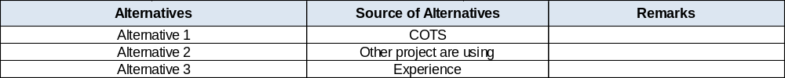
- Identify the criteria for evaluation and assign weight to each criterion based on the importance of the criteria. The importance of criteria may depend upon the problem or decision scenario.
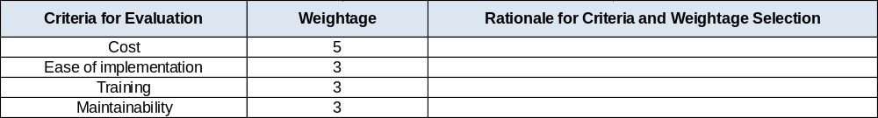
Weightage are assigned on the scale of 1 to 5 (1 = Least important and 5 = Most important).

- Record the rationale for assigning weight to criteria.

- Score the alternatives against each criteria on the scale of 1 to 5 (1 being least value and 5 being the highest value).

- Weighted score is computed (automatically) based on weight and score assigned.

- Average weighted score for each alternative is computed.
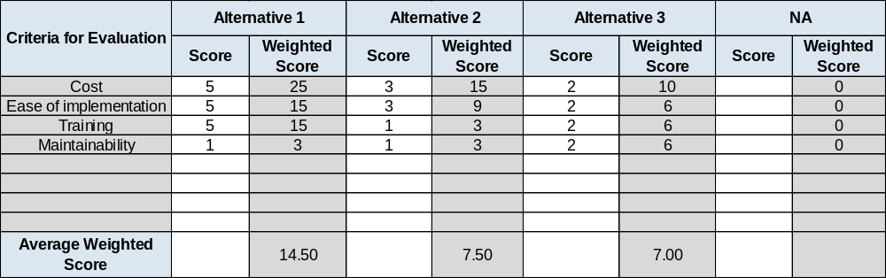

- The average scores are ranked.

- The alternative with maximum average score is ranked 1 and is accepted.

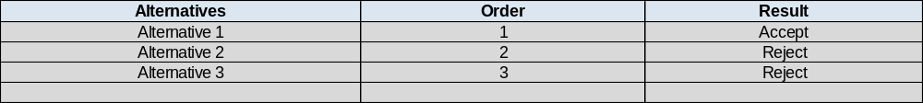

Role based decision authority matrix:
Following authority matrix should be referred to identify authorized role holder while analyzing possible scenarios using formal evaluation process.

Role ‎‎ | Delivery Head / HOD | SEPG Head | Project Manager | Tech Lead | Business Analyst
Activity
Milestone sign-off related decision | ✓
Project management, plan related decision |  |  | ✓
Technology selection |  |  | ✓
Requirement’s solution approach related |  |  |  |  | ✓
Technical solution approach related |  |  |  | ✓
Invoice clearance | ✓
Any Process Tailoring Request |  | ✓
Any Template Deviation Request |  | ✓
Release clearance / Release audit |  | ✓
Timesheet related |  |  | ✓
Subcontractor related | ✓

